Unethical Behavior of Business Students at Bo Diddley Tech
Student’s name:
Institutional Affiliation:

Introduction
The purpose of this assessment was to evaluate the problem of cheating when it comes down to two categories of students: Business Athlete and Non-business Athlete. The data that was provided on the task was used to create a pivot table and bar graph to demonstrate from a sample of 60 students where cheating mostly occurred. Providing this report brings to light the problems that need to be addressed to prevent them from occurring in the future.
Data set used
The data set I used in the assessment was provided. From the data set, I was able to see students that were athletes, the non-athletes, and those that cheated. From the 240 students that had data presented on their behalf, I was asked to choose at least 60 students which assisted me in organizing the numbers. Being able to see the smaller amount of student's data made it easy to evaluate the number of students cheating from both categories. For example, 20 out of the 33 students were business athletes and from the rest of the data, it showed that only 7 out of 20 students actually cheated as compared to the national average which is 57%. The number of students that had cheated reached 85%. From the collected data, we can see the areas that need to be improved by the school and in what way they can solve or avoid the problem of cheating from both athletes and non-athletes
Data organization, visualization and findings
Through the pivot table, we can see the categories of students that are being evaluated within the assessment. In the table, the students are organized as Business Athlete or Non-Business Athlete, showing the cheating count of each category and the total students in each category. For example, the pivot table shows an overall of 33 Business students and out of all athlete and non-athlete students, 18 cheated. Whether cheating as an athlete or not, the act tarnishes the school image. The pivot table also show the data collected from other students. Last but not least, the pivot table provides an overlook of the total amount of numbers and students being looked over in the report. The bar chart below shows the two categories through color coordination to enhance visual representations of the student cheaters and none—cheaters.
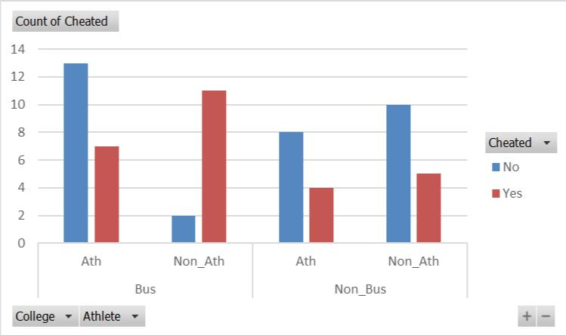
My overall summary from the four population proportion hypothesis tests is that I did not expect the outcomes to be below national average. However, I did suspect that with a select of 60 students, the outcomes would be greater due to less students being used for the report in general. This section allowed me to see that because the number of students used in the hypothesis was higher and not all students were declared as cheaters. Another valuable aspect drawn from the hypothesis is that it incorporated the expelled students which helps in retaining the good image of the school when it comes down to cheating.
Ethical summary
The dean has expressed himself how most would have done when it comes down to the school reputation and the students’ pride in it. The data was collected in an honest manner because it is unethical to ‘tweak; with the school image whereas the issue is solvable and can be avoided in future. Manipulating the statistical data can lead to greater problems for the school that would cause far more damage than good. Therefore, after evaluating the collected data, there would not be any need to ‘tweak’ with the school image based on the outcome. Given that there was a total of 240 students and 60 were used for the report the dean can see where to go from here as far as looking at cheaters and the data.
Conclusion
In conclusion, I would advise the dean to look into the data carefully in order to come up with ways to avoid and solve such problems when they arise. Not all students are cheaters according to the information provided, therefore the issue can be fixed. Given that there are two categories to look at, athletes and non-athletes, the dean can outweigh the pros and cons for each category in his assessment and of course also assess the other students with the same issue. If worse comes to worst, the caught cheaters must be disciplined but in a way of providing restoration. Overall, this report has shown that the students who cheat more are the business/non-athlete students and not so much the business students.

